Experiment no.:05 Keerthika.K-241901046
View Last Activity of Your PC
Aim
To view the last activity of a PC using LastActivityView.
Procedure
- Download and open the LastActivityView tool on a Windows operating system.
- Allow the tool to collect information from various sources on the running system.
- View the log of actions performed by the user and events that occurred on the computer.
- Examine the available activity records displayed by the tool.
- Identify the relevant user activities and system events from the displayed log.
- Record the observations for forensic investigation.
Observation
LastActivityView is a tool for the Windows operating system that collects information from various sources on a running system and displays a log of user actions and events that occurred on the computer.
Observation Table
S. No. | Particulars | Observation
1 | Tool Used | LastActivityView
2 | Operating System | Windows
3 | Purpose | To view the last activity of the PC
4 | Information Collected | User actions and system events
5 | Activity Log | As displayed by LastActivityView
6 | Forensic Evidence | Activity records available in the tool
7 | Status | Record based on the actual tool output

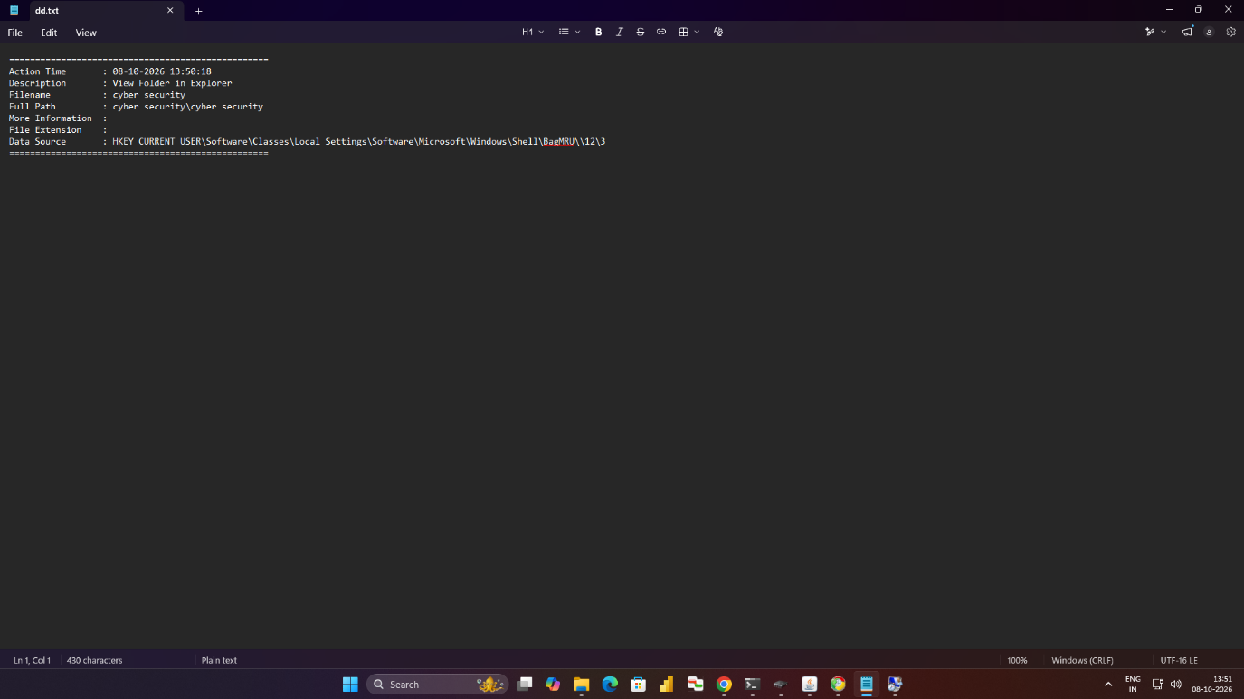

Result
Thus, the LastActivityView forensic tool was used to view the available activity records of the PC, and the displayed user actions and system events were examined for forensic investigation.

